

컴퓨터 알고리즘과 실습 1주차 보고서

2016112158 김희수

문제1번

<1-1> 유사코드 작성

accumulate_average(array):

    sum = 0

    for i = 1 to Length(array):

        sum+=array[i]

        return sum/(i+1)

<1-3실행화면>

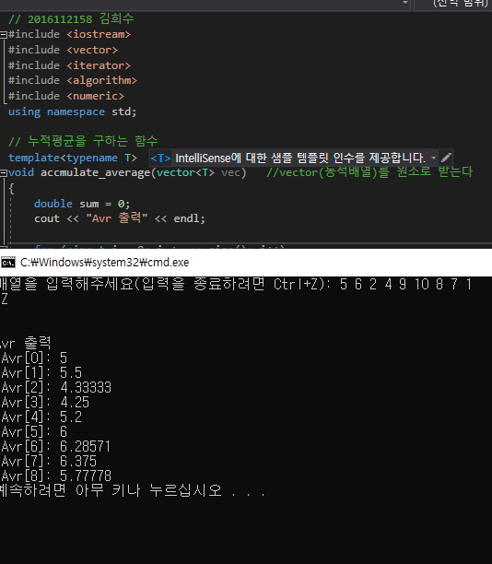

문제2번

<2-1 GreedyBetterChange 유사코드>

GreedBetterChange(Money, coin, d):

    for i := d to 1

        k[i] := M/c[i] //k is array. k1, k2, ... , kd

        M := M - c[i] * k[i]

    return k

<2-3 BruteForceChange 유사코드>

BruteForceChange(coinValueList, total, numCoins, coinDict):

    for i := 0 to length(coinValueList):

        coinDict[coinValueList[i]]

    if total == 0:

        return (numCoins, coinDict)

    bestCoins := -1

    bestDict := make_dictionary()   // make empty dictionary

    for i := 0 to length(coinValueList):

        dictCopy := make_dictionary()

        for i:=0 to length(coinValueList):

            dictCopy[coin] = coinDict[coin]

        coin := conValueList[i]

        if coin <= total:

            dictCopy[coin] += 1

            (subCoins, subDict) := BruteForceChange(coinValueList, totla-coin, numCoins+1, dictCopy)

            if bestCoins == -1 && subCoins < bestCoins:

                bestCoins := subCoins

                bestDict := subDict

    return (bestCoins, bestDict)

<2-2, 2-4 실행화면>

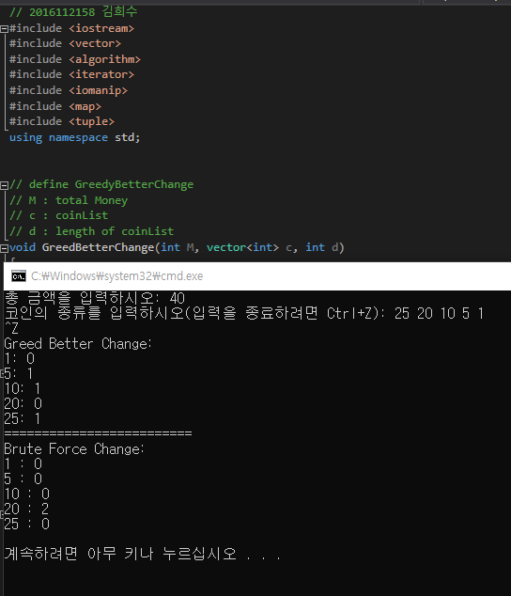

<2-5 GreedyBetter과 BruteForce가 값이 다른경우>

c={55,22,15,10,7,1}

